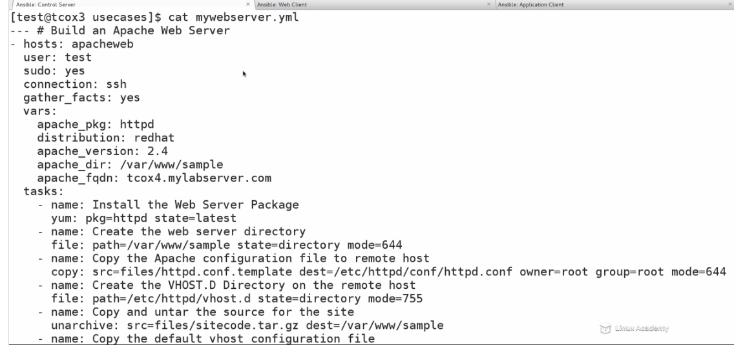

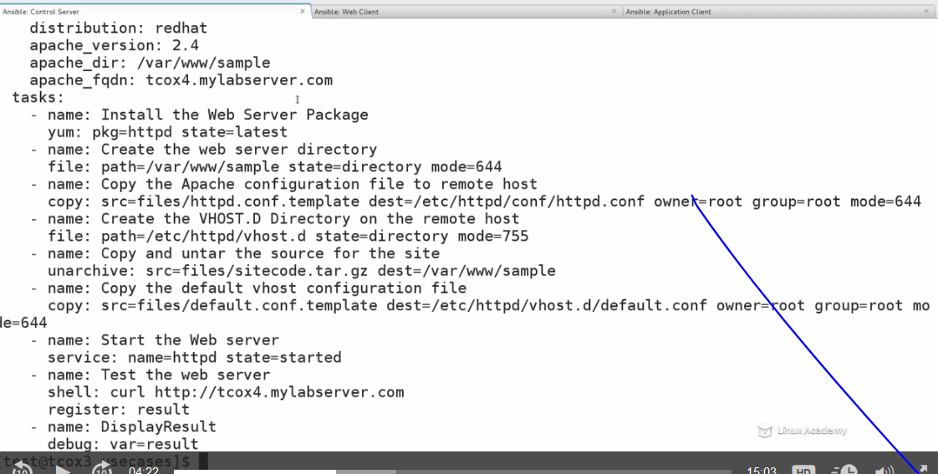

Now that we have spent a lot of time on Playbooks and Roles, let's create some Use Cases and step through: 1. Creating an outline of what we want to do and how to do it 2. Translate it to an Ansible Playbook 3. Break it apart into an Ansible Role

After optimization :

